IT-511 Stepping Stone Lab 1: Pseudocode

Joshua T. Pierce

Southern New Hampshire University

**Problem Overview**

This program will help manage a collection of recipes. Recipes will be managed as three major objects (classes): Ingredients, Recipes, and the Collection. The Collection will contain Recipes which will contain Ingredients as demonstrated in the following diagram:

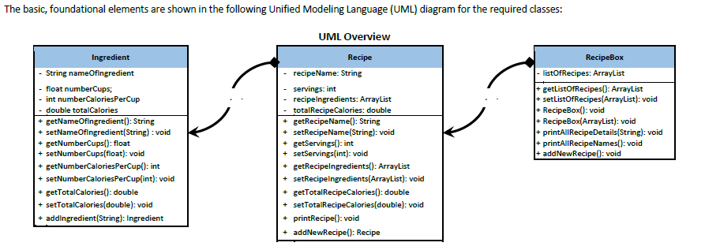

Some information will be entered by the user. Other information will be automatically calculated by the program. The Recipe Box will be the primary object the user interacts with and also the name of the “main” function where the following options are presented:

- Add New Recipe

- Add New Ingredient

- Print the Details of a Recipe

- Print the Details of an Ingredient

- See List of All Recipes

- See List of All Ingredients

- Delete a Recipe

- Delete an Ingredient

- Exit

**Visio Flowchart/Diagram:**

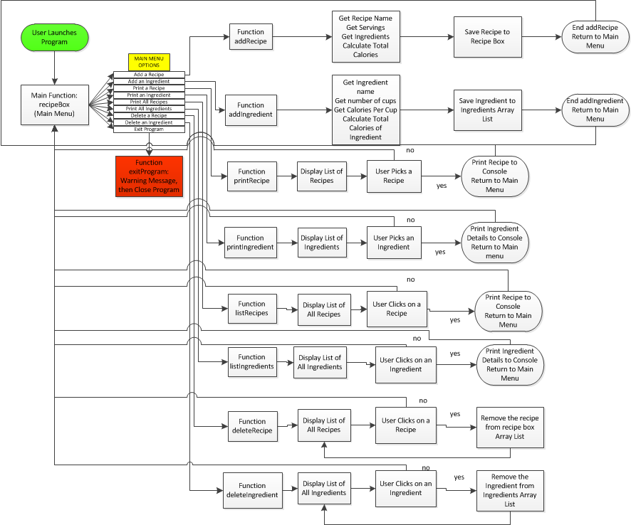

**Pseudo Code:**

**/*Variable Definitions*/**

/*Ingredient*/

Define listOfIngredients as an ArrayList (void, no members)

Define string nameOfIngredient, set to void

Define float numberOfcups, set to void

Define integer numberCaloriesPerCup, set to void

Define double totalCalories, set to void

/*Recipe*/

Define recipeIngredients as an ArrayList (void, no members)

Define string recipeName, set to void

Define integer servings, set to void

Define double totalRecipeCalories, set to void

/*Recipe Box*/

Define RecipeBox = listOfRecipes

Define listOfRecipes as an ArrayList (void, no members)

**/* Main Function: Open Recipe Box with Options */**

Begin function recipeBox( ):

If user selects “Add a Recipe”

Go to function addRecipe;

Else if user selects “Add an Ingredient”

Go to function addIngredient

Else if user selects “View a Recipe”

Go to function printRecipe;

Else if user selects “View an Ingredient”

Go to function printIngredient

Else if user selects “See List of all Recipes”

Go to function listRecipes;

Else if user selects “See List of all Ingredients”

Go to function listIngredients;

Else if user selects “Delete a Recipe”

Go to function deleteRecipe;

Else if user selects “Delete an Ingredient”

Go to function deleteIngredient;

Else user selects “Exit”

Go to function exitProgram;

End function recipeBox( );

**/*Add a Recipe*/**

Begin function addRecipe( ):

function getRecipeName //Prompt user for recipe name

function getServings //Prompt user for number of servings

function getRecipeIngredients

Bring up list of all ingredients for user to select

function calculate totalRecipeCalories

for each member of recipeIngredients,

totalRecipeCalories = sum of totalCalories

Save recipe to listOfRecipes

End function addRecipe( );

**/*Add an Ingredient*/**

Begin function addIngredient( ):

function getNameOfIngredient //Prompt user for ingredient name

function getNumberOfCups //Prompt user for number of cups

function getCaloriesPerCup //Prompt user for calories per cup

function totalCalories

totalCalories = numberOfCups * caloriesPerCup

Save ingredient to listOfIngredients

End function addIngredient( );

**/*View a Recipe*/**

Begin function printRecipe( ):

Display list of all recipes

If user selects a recipe

Print that recipe

Else if user does not select a recipe

Return to home screen

End function printRecipe( );

**/*View an Ingredient*/**

Begin function printIngredient( ):

Display list of all ingredients

If user selects an ingredient

Print that ingredient

Else if user does not select an ingredient

Return to recipeBox

End function printIngredient( );

**/*List all Recipes*/**

Begin function listRecipes( ):

Print listOfRecipes

If user selects a recipe

Print recipe details to console

Else if user does not select a recipe

Return to recipeBox

End function listRecipes( );

**/*List all Ingredients*/**

Begin function listIngredients( ):

Print listOfIngredients

If user selects an Ingredient

Print recipe details to console

Else if user does not select an Ingredient

Return to recipeBox

End function listIngredients( );

**/*Delete a Recipe*/**

Begin function deleteRecipe( ):

Display list of all recipes

If user selects a recipe

Print “Are you sure you want to delete this recipe?”

If user selects “yes”

Delete the recipe

Return to list of recipes

Else if user selects “no”

Return to list of recipes

Else if user does not select a recipe

Return to recipeBox

End function deleteRecipe( );

**/*Delete an Ingredient*/**

Begin function deleteIngredient( ):

Display list of all ingredients

If user selects an ingredient

Print “Are you sure you want to delete this ingredient? This ingredient will be removed from any recipes it is a part of.”

If user selects “yes”

Delete the ingredient

Return to list of ingredients

Else if user selects “no”

Return to list of ingredients

Else if user does not select an ingredient

Return to recipeBox

End function deleteIngredient( );

**/*Exit the Program*/**

Begin function exitProgram

Display “Are you sure you want to exit? Any unsaved changes will be lost.”

If user selects “Yes,”

Exit Program

Else user selects “No,”

Return to function recipeBox;

End function exitProgram.